NEPAL COLLEGE OF INFORMATION TECHNOLOGY
BALKUMARI, LALITPUR
Level: Bachelor Semester- Fall Year: 2015
Programme: BE Full Marks: 100
Course: Network Theory Time: 3 hrs.
Candidates are required to give their answers in their own words as far as practicable.
The figures in the margin indicate full marks.
Assume suitable data if necessary.
Attempt all the questions.
- a) In the following circuit, switch k is changed from position 1 to position 2 at time t=0, steady state condition having reached before switching. It is required to find i, di/dt, d²i/dt² at time t= 0⁺. [7]
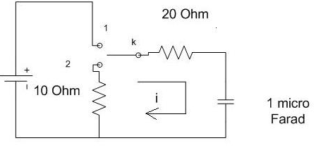
b) In the given circuit below, capacitor C has an initial voltage V_{C} (0⁻ ) = 10 Volts and at the same instant current in the inductor L is zero. Switch k closed at time t=0. Obtain expression for the voltage v(t) across the inductor L using classical approach. [8]
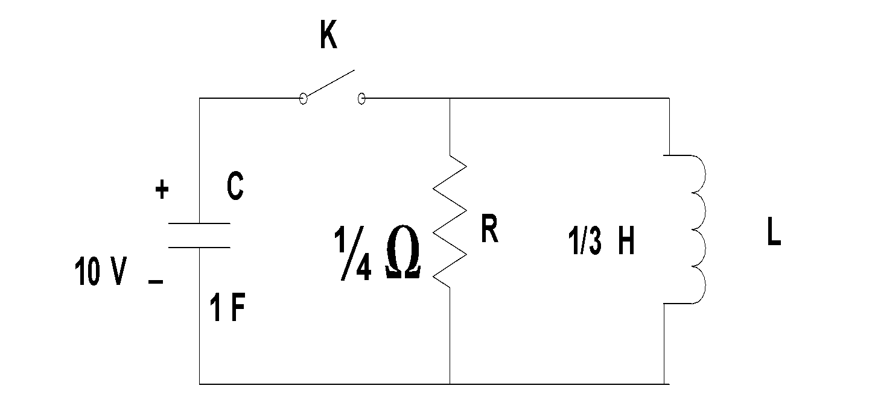
- a)Derive an expression for instantaneous current i(t) for a series circuit comprising of Resistor R and inductor L when excited by exponential driving force. [7]

b) In the series R-L-C circuit with R=200 Ω, L=0.5H and C=100 µF has a sinusoidal voltage source V= 300 Sin(500t + 30⁰), find the resulting current by using classical approach. Assume switch is closed at t=0 sec. [8]

- a)An exponential current 2e^{-3t} is applied at time t=0 to a parallel R-C circuit compromising resistor R= 0.5 Ω and capacitor= 1 F. Obtain complete solution for voltage v(t) across the network. Assume zero charge across the capacitor before the application of current. Use Laplace transform method [8]

b) ) Using Laplace transform function solve the following differential equation.
. Given that , [7]

- a) Find the trigonometric Fourier series for the waveform shown in figure below. [7]
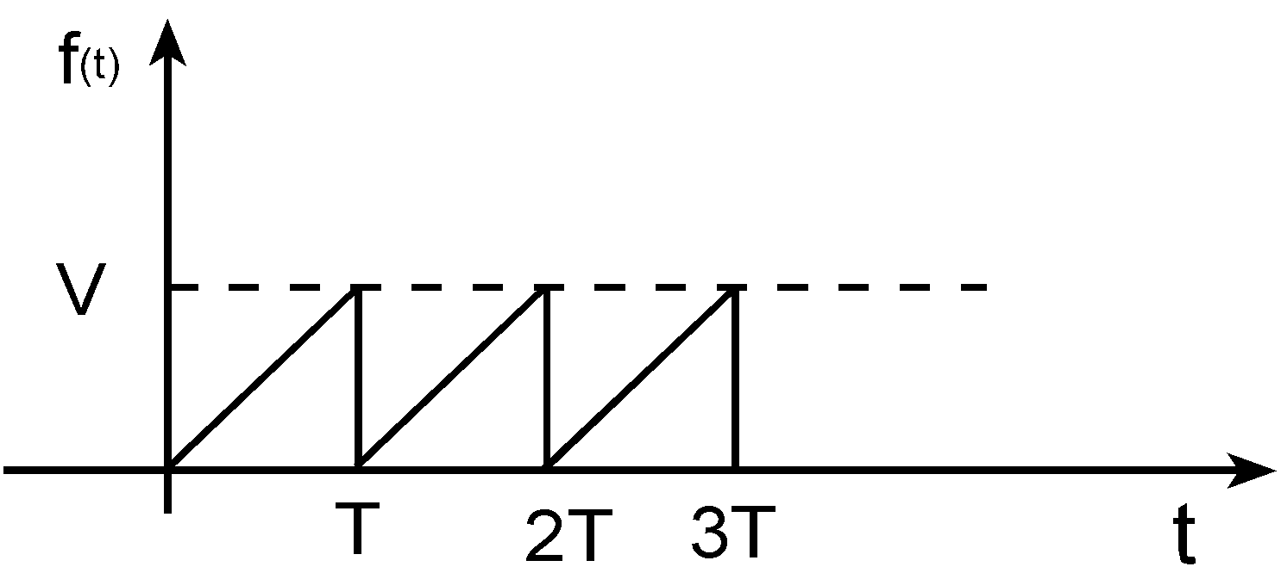

b) Determine the range of k so that the system given by characteristic equation is stable by using Routh’s Tabulation. [8]

5 a) Derive the condition for positive real function assuming other conditions are satisfied. [7]
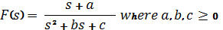
b) Which of the following functions are L-C driving point impedances? Why?
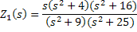

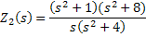
And, synthesize the realizable impedances in a Foster –I form. [8]
6 a) Find the open circuit parameters of given network. [8]
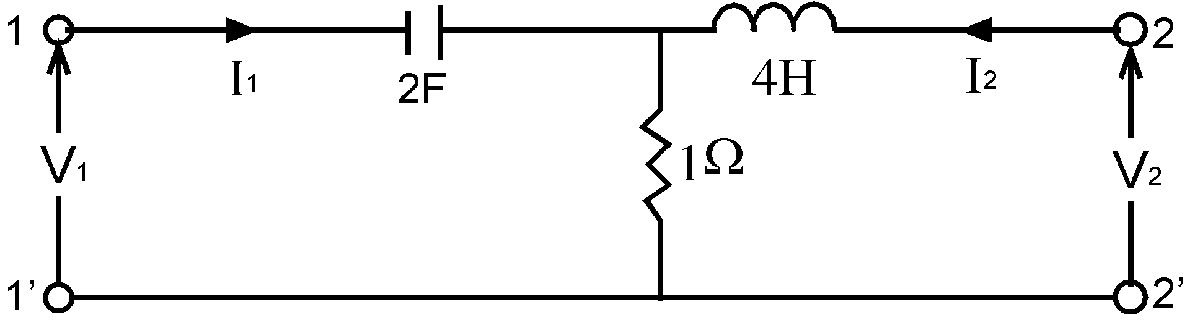
b) Find the equivalent T-network for given π- network [7]
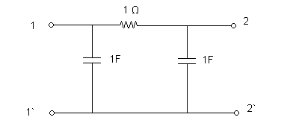
7. Write short notes on (Any Two) 2×5
a) Properties of Positive Real Function
b) Filter and its Types
c) Reciprocity and symmetry of Two-Port Network

